# Task P5.1.4

## Create Student Table:

CREATE TABLE Student(

-> stud_id MEDIUMINT(9) UNSIGNED NOT NULL,

-> stud_name VARCHAR(30) NOT NULL,

-> stud_phone MEDIUMINT(10) UNSIGNED NOT NULL,

-> stud_date_of_birth DATE NOT NULL,

-> stud_city VARCHAR(28) NOT NULL,

-> stud_address TINYTEXT NOT NULL,

-> stud_postcode SMALLINT(4) UNSIGNED NOT NULL,

-> PRIMARY KEY (stud_id)

-> );

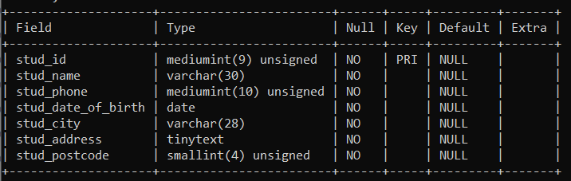

## Create Subject Table:

CREATE TABLE Subject(

-> subj_code char(8) not null,

-> subj_title varchar(30) not null,

-> PRIMARY KEY (subj_code)

-> );

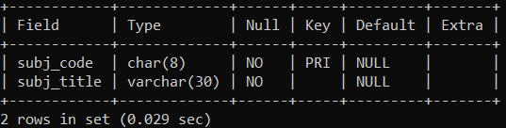

## Creating Student table:

CREATE TABLE Subj_Enrolment(

stud_id mediumint(9) unsigned not null,

subj_code char(8) not null,

semester smallint(1) not null,

year YEAR not null,

comment tinytext,

PRIMARY KEY (stud_id, subj_code, year, semester),

FOREIGN KEY (stud_id) REFERENCES Student(stud_id),

FOREIGN KEY (subj_code) REFERENCES Subject(subj_code)

);

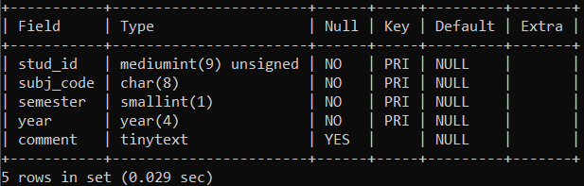

## Create Grade Table:

CREATE TABLE Grade(

-> stud_id MEDIUMINT(9) UNSIGNED NOT NULL,

-> subj_code CHAR(8) NOT NULL,

-> semester SMALLINT(1),

-> year YEAR NOT NULL,

-> grade CHAR(2) NOT NULL,

-> PRIMARY KEY (stud_id, subj_code, year, semester),

-> FOREIGN KEY (stud_id) REFERENCES Student(stud_id),

-> FOREIGN KEY (subj_code) REFERENCES Subject(subj_code),

-> ADD FOREIGN KEY (semester, year) REFERENCES subj_enrolment (semester, year)

-> );

